Civil war in Sierra Leone

UNSC Resolution: | 1132
Date of adoption: | 8 October 1997
Operative paragraph: | 1
Demand number: | 1

Megan MacKenzie

Wording of demand
take immediate steps to relinquish power in Sierra Leone and make way for the restoration of the democratically-elected Government and a return to constitutional order

List of addressees of the demand

Military Junta (Sierra Leone)

Short-term compliance

Description of the addressee(s)’ conduct

Shortly thereafter [Passing of Security Council Resolution 1132], Koroma formally agreed to relinquish power. Meeting with representatives of regional and international organizations in the Guinean capital in October 1997, Koroma signed the Conakry Agreement, which called for Kabbah to be reinstalled by April 1998. 149

6. Clashes between AFRC troops and ECOMOG forces were reported to have taken place in Freetown and around July, 25 kilometres from Freetown, where ECOMOG troops are based and were attacked by the AFRC.

To date, it appears that the military junta has not complied with
paragraph 1 of resolution 1132 (1997).

Assessment

Short-term compliance
x No or marginal compliance (1) | Medium low compliance (2) | Medium high compliance (3) | Full or almost full compliance (4)

Considerations underlying the assessment
There is evidence of verbal commitment to this command by the Military Junta, yet their actions show clear violations of the demand. The Security Council Report makes it clear that this demand was not complied with.

Medium-term compliance

Description of the addressee(s)’ conduct

Soon after the Conakry Agreement was concluded [January 1998], however ,it became apparent to many that Koroma could not hold up his end of the bargain.....

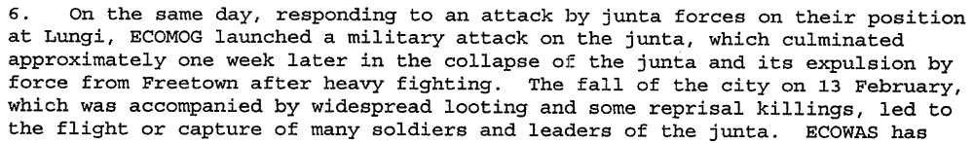

Assessment

Medium-term compliance
x No or marginal compliance (1) | Medium low compliance (2) | Medium high compliance (3) | Full or almost full compliance (4)

Considerations underlying the assessment
The demand is clear that the Junta should take ‘immediate steps to relinquish power.’ The Junta lost power during this period of time but it was through force, not as a result of relinquishing it.

Depth of demand

Assessment

Level of depth of demand
Low depth of demand (1) | Medium depth of demand (2) | x High depth of demand (3)

Considerations underlying the assessment
For the Junta, relinquishing power and making way for a democratically elected government required a drastic alteration of the entire raison d’etre. They had achieved power through force and had removed a democratically elected government.

Level of confidence about coding decisions

Level of confidence about coding decision
Extremely high | x High | Moderate

Comments to IPI (if any)

Civil war in Sierra Leone

UNSC Resolution: | 1132
Date of adoption: | 8 October 1997
Operative paragraph: | 2
Demand number: | 1

Megan MacKenzie

Wording of demand

end all acts of violence and cease all interference with the delivery of humanitarian assistance to
the people of Sierra Leone

List of addressees of the demand

Military Junta (Sierra Leone)

Short-term compliance

Description of the addressee(s)’ conduct

13. The serious humanitarian situation in the country poses a dilemma for the international community because the security and safety of both personnel and humanitarian supplies cannot be assured in the country under prevailing conditions.

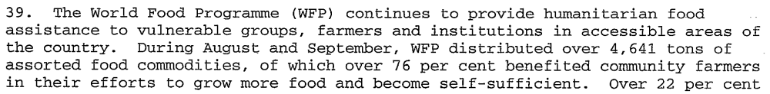

Assessment

Short-term compliance
x No or marginal compliance (1) | Medium low compliance (2) | Medium high compliance (3) | Full or almost full compliance (4)

Considerations underlying the assessment
There is strong evidence of continued hostilities initiated by the Junta in the country during this period of time. The research also indicates that some humanitarian assistance was being carried out, but that the security situation in the country was hindering this process.

Medium-term compliance

Description of the addressee(s)’ conduct
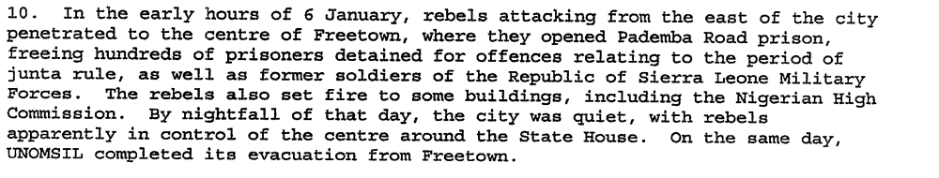
In February 1998, Nigerian troops….launched an assault on rebel-held Freetown. Koroma and the AFRC were driven from power by the end of February, and Kabbah returned to Freetown on March 10, 1998. The West African force did not fully neutralize the AFRC and RUF threat, however, and fighting continued in the eastern and norther parts of the country. By December, the RUF was advancing from the east toward Freetown…Some accounts mention only the RUF role in the subsequent siege of Freetown, but numerous credible sources credit the ex-SLA/AFRC with organizing the attack, in which some RUF troops participated.

Assessment

Medium-term compliance
x No or marginal compliance (1) | Medium low compliance (2) | Medium high compliance (3) | Full or almost full compliance (4)

Considerations underlying the assessment
There was intense fighting during this period and the AFRC/RUF caused drastic instability during this period of time.

Depth of demand

Assessment

Level of depth of demand
Low depth of demand (1) | Medium depth of demand (2) | x High depth of demand (3)

Considerations underlying the assessment
Ending all acts of violence was a high depth demand because at this point, the AFRC and RUF had gained most of the power and authority through force. They were formed as an armed group, not a political party.

Level of confidence about coding decisions

Level of confidence about coding decision
Extremely high | x High | Moderate

Comments to IPI (if any)

Eric G. Berman and Melissa T. Labonte, “Sierra Leone” in William J. Durch ed. Sierra Leone 21st Century Peace Operations. (Washington: United States Institute of Peace) p141.
United Nations Secretary General. REPORT OF THE SECRETARY-GENERAL ON THE SITUATION IN SIERRA LEONE. 21 October 1997
United Nations Secretary General. REPORT OF THE SECRETARY-GENERAL ON THE SITUATION IN SIERRA LEONE. 21 October 1997
Eric G. Berman and Melissa T. Labonte, “Sierra Leone” in William J. Durch ed. Sierra Leone 21st Century Peace Operations. (Washington: United States Institute of Peace) p149.
United Nations Secretary General. First Progress Report of the Secretary General on UNOMSIL. 12 August 1998.
United Nations Security Council. Second Progress Report of the Secretary General on UNOMSIL with plans for later phases of deployment. 16 October 1998.
United Nations Secretary General. REPORT OF THE SECRETARY-GENERAL ON THE SITUATION IN SIERRA LEONE. 21 October 1997
United Nations Secretary General. Second Progress Report of the Secretary General on UNOMSIL with plans for later phases of deployment. 16 October 1998.
United Nations Secretary General. Special report of the Secretary-General on UNOMSIL, containing updated information and revised observations and recommendations 7 January 1999.
Eric G. Berman and Melissa T. Labonte, “Sierra Leone” in William J. Durch ed. Sierra Leone 21st Century Peace Operations. (Washington: United States Institute of Peace) p155.

